|  |
| --- |
| **E:\My Documents\Desktop\Logo_FPT_University_doc.jpgMinistry of education and training** |
| Software User’s Manual |
| Place Sharing Network |
|  |
| |  |  | | --- | --- | | **PSN Team** | | | **Group Members** | Võ Thanh Quảng – 00308 – QuangVT00308  Lê Minh Quang – 00518 – QuangLM00518  Trương Quang Dũng – 00440 – DungTQ00440  Nguyễn Minh Quốc – 00319 – QuocNM00319  Nguyễn Minh Vượng – 00335 – VuongNM00335 | | **Supervisor** | Teacher Huỳnh Anh Dũng | | **Ext Supervisor** |  | | **Capstone Project code** | PSN | |
| **Hanoi, 10th Apr, 2011** |

**Record of Changes**

|  |  |  |  |  |
| --- | --- | --- | --- | --- |
| **Date** | **Change Item** | **Description** | **By** | **Version** |
| 08/04/2011 | All | Create the document | DungTQ | 0.1 |
| 10/04/2011 | Add new item | Add Admin Guide and General Guide | DungTQ | 0.2 |
| 10/04/2011 | Add new item | Add form guide, add manage spam, edit other item | QuangLM | 0.3 |
| 10/04/2011 | Format | Format all document | QuangLM | 0.4 |
| 10/04/2011 | Installation Guide | Create installation guide | QuangVT | 0.5 |
| 24/4/2011 | Version | Finalize to version 1.0 | QuangVT | 1.0 |

# Table of Contents

[Table of Contents 2](#_Toc290911081)

[I. Installation Guide 3](#_Toc290911082)

[1. Setting up the environment at server side 3](#_Toc290911083)

[2. Deployment at server side 3](#_Toc290911084)

[2.1 Prepare deployment package 3](#_Toc290911085)

[2.2 Deploy Database 3](#_Toc290911086)

[2.3 Deploy web application 5](#_Toc290911087)

[2.4 Change configurations 9](#_Toc290911088)

[3. Setting up the environment at Client side 10](#_Toc290911089)

[II. User’s Guide 11](#_Toc290911090)

[1. General Guide 11](#_Toc290911091)

[3.1 Login 11](#_Toc290911092)

[3.2 View your profile 12](#_Toc290911093)

[3.3 Quick Search 14](#_Toc290911094)

[3.4 View place details 15](#_Toc290911095)

[3.5 View question and answer 18](#_Toc290911096)

[3.6 View other user’s profile 20](#_Toc290911097)

[2. Form Guide 21](#_Toc290911098)

[2.1 Register a new PSN account and Activation 21](#_Toc290911101)

[2.2 Forgot password 23](#_Toc290911102)

[2.3 Create a new place 24](#_Toc290911103)

[2.4 Create a new question 27](#_Toc290911104)

[2.5 Create an answer 28](#_Toc290911105)

[2.6 Create a new contact 29](#_Toc290911106)

[3. Admin Guide 30](#_Toc290911107)

[3.1 Manage Places 30](#_Toc290911111)

[3.2 Manage Spam 31](#_Toc290911112)

[3.3 Manage Users 35](#_Toc290911113)

[3.4 Manage Categories 38](#_Toc290911114)

[3.5 Manage Address Parts 39](#_Toc290911115)

[3.6 Manage Contacts 40](#_Toc290911116)

[III. Others 41](#_Toc290911117)

# Installation Guide

## Setting up the environment at server side

The following software must be installed into the server machine:

* Windows Server 2008 operating system
* Internet Information Services (IIS) 7.5
* SQL Server 2008 R2
* .NET Framework 4.0

## Deployment at server side

### Prepare deployment package

* Extract the deployment package to a folder on the server

For example: D:\Temp\PSN\_Deployment\_Package

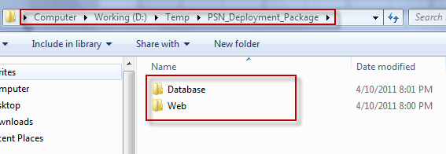

### Deploy Database

* Open Microsoft SQL Server Management Studio (SSMS)
* Create a database named PSN

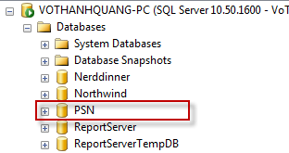

* Open file <deployment\_package>\Database\Schemas\Database Schemal.sql in SSMS
* Change working database in SSMS to PSN

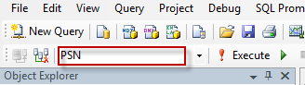

* Press F5 to run the script. Data tables should be created for PSN database

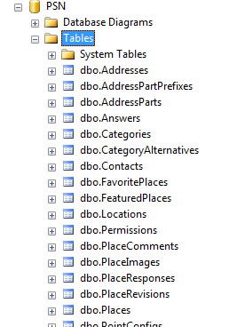

* Open file <deployment\_package>\Database\Data\PSN\_Reference data.sql in SSMS
* Press F5 to run the script. Reference data should be inserted to PSN database. For example the following is data of Permissions table:

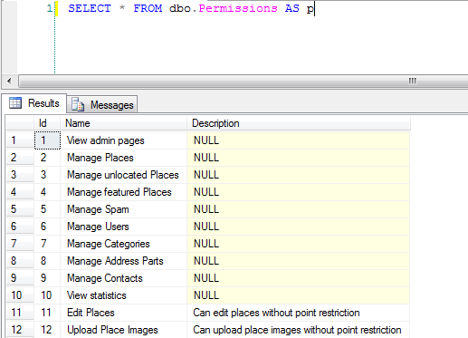

* The database contains one user with login account: [admin@place.vn/123456](mailto:admin@place.vn/123456). This user has full privileges to the system.

### Deploy web application

* Register ASP.NET with IIS: open command line tool with admin privilege, change working folder to C:\Windows\Microsoft.NET\Framework64\v4.0.30319

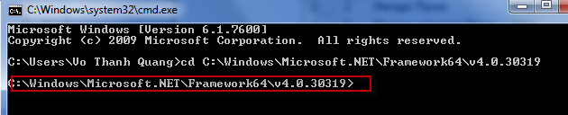

* Type aspnet\_regiis –i and press enter to register ASP.NET 4.0 to IIS

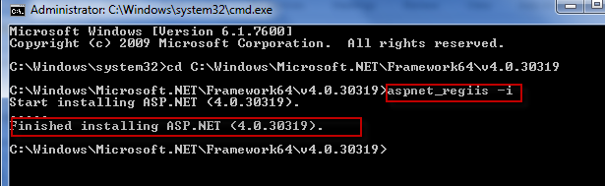

* Open IIS by opening start menu, type iis and press enter

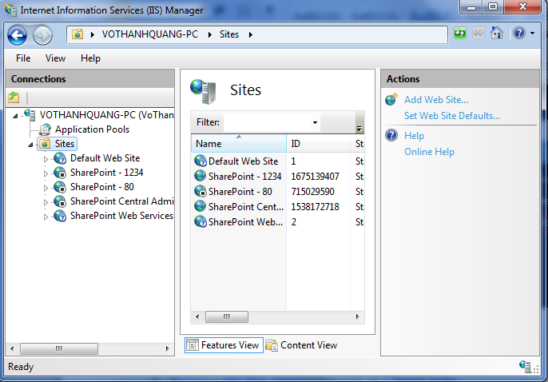

* Select Application Pools menu on the left menu bar, then select DefaultAppPool, click on Advanced Settings menu on the right bar, then open Identity window, choose Built-in account as LocalSystem:

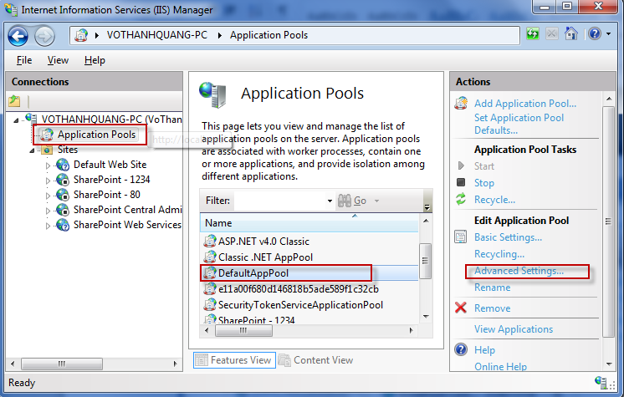

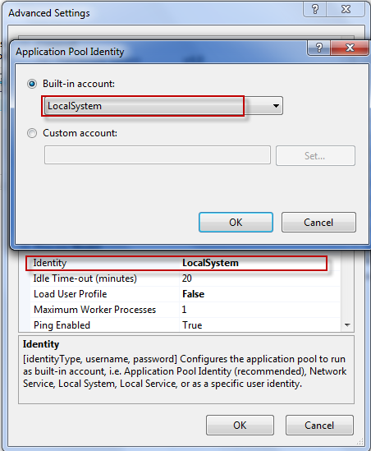

* Copy contents of <deployment\_package>\Web folder to another working folder. This folder will be the physical path of the web app. For example: D:\Apps\PSN

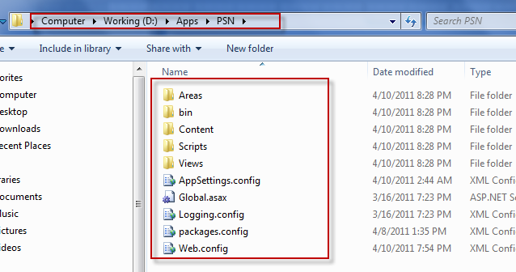

* Back to IIS Manager windows, create an application for Default Web Site named psn

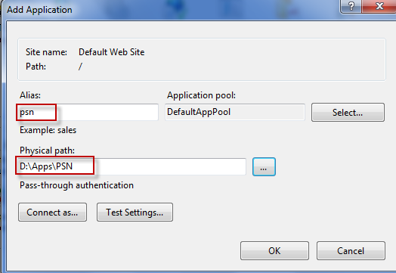

* Test the application by entering localhost/psn/ in to address bar of the browser. The application should show up:

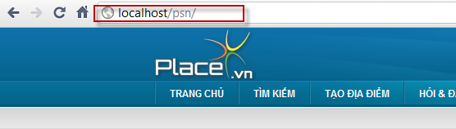

* Try logging in with admin account: [admin@place.vn/123456](mailto:admin@place.vn/123456). The system should log you in successfully.

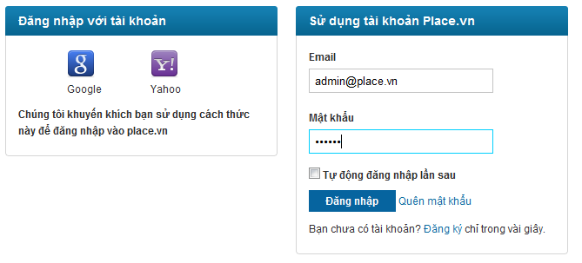

### Change configurations

#### Change logging config

* Open file Logging.config in the application physical path
* Change the log files for errors and general to an absolute file path or relative file path to the application

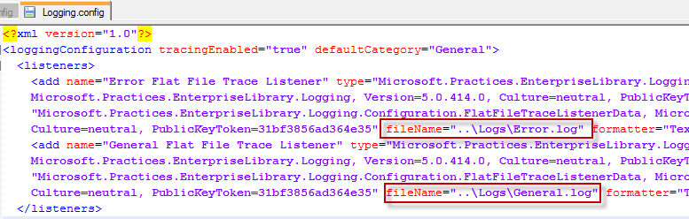

#### Change system config

* Open file AppSettings.config in the application physical path

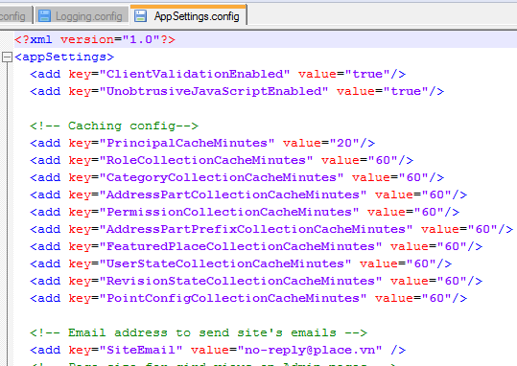

* Change config values appropriately

## Setting up the environment at Client side

The system is accessed via web browsers. The client machine should be installed with one of the following browsers: Firefox 3.0 and higher, Chrome, Internet Explorer 7.0 and higher, Opera 11 and higher.

# User’s Guide

## General Guide

### Login

#### Login with Google or Yahoo account

**Method 1:**

There are some actions that require the user to be logged in. A message will show up as following:

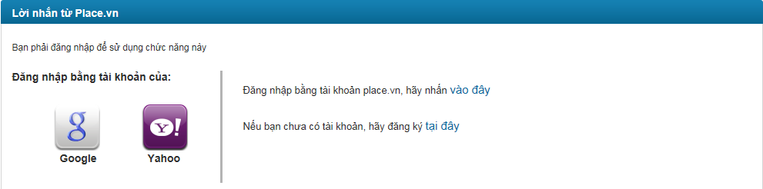

Click on Google or Yahoo icon to login with those providers’ accounts.

**Method 2**:

Click “Đăng nhập” button at the top of the page:

C:\Users\iLucas\Desktop\reg panel.png

The user will be redirected to the login page

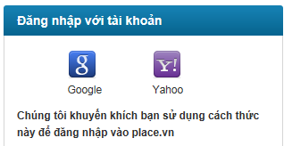

Click Google or Yahoo icon.

Notice: If this is the first time you login into website, you will be redirected to login page of Google or Yahoo. After you enter username and password and click sign in, you need to confirm to use your existing account to login place.vn.

#### Login with PSN account

**Method 1:**

There are some actions that require the user to be logged in. A message will show up as following:



Click “vào đây” hyperlink and you will be redirected to login page

**Method 2**:

You can click “Đăng nhập” button at the top of the page

C:\Users\iLucas\Desktop\reg panel.png

You will be redirected to login page

Login page:

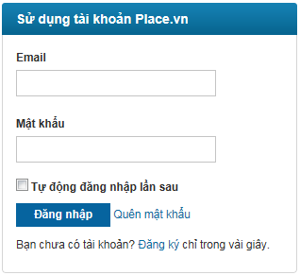

Enter your email and password and click “Đăng nhập” button to log into our system.

You can check “Tự động đăng nhập lần sau” box to save time of logging into the system again later.

### View your profile

Click your username at login panel at the top right corner of the website will get you redirected to your Profile page. This page has 2 tabs as the following picture:

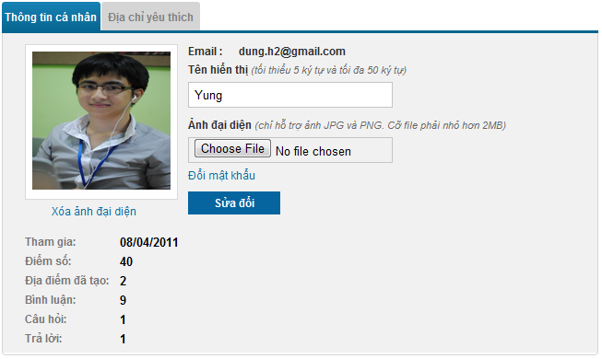

* “Thông tin cá nhân” tab
* At this tab, you can view some information of yourself: email, registered date, current point, number of places created, number of comments, questions and answers posted. Besides, you can easily change other information including: Display Name, Avatar and password.
* After changing some information, you have to click “Sửa đổi” button to save the changes.
* You can change your avatar but its type must be JPG or PNG and its size must be smaller than 2MB.
* If you want to change password, you can click “Đổi mật khẩu” hyperlink, a popup will appear.

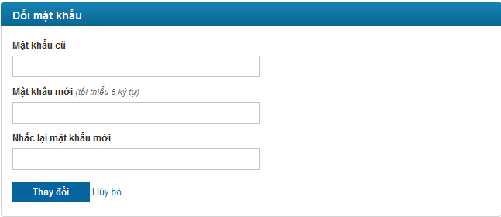

You have to type old password, new password and confirmed password before clicking “Thay đổi” button to change password. If you want to cancel this action, you can click to “Hủy bỏ” hyperlink to redirect to View Profile page.

* “Địa chỉ yêu thích” tab

All your favorite places will be shown at here. Each place has place name, rating, address, comment number and view number.

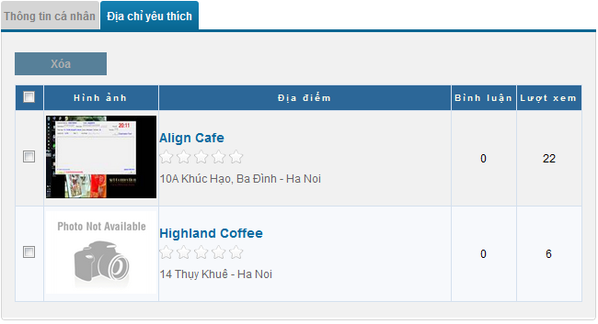

Each place’s name is a hyperlink which allows you to [view place details](#_View_place_details_1) information. You can also delete some places from list by tick boxes beside place which you want to delete and click to “Xóa” button at the top of list. You can check all boxes quickly by tick first checkbox which besides “Hình ảnh” title.

### Quick Search

Search is the most used function in almost every website. You can access to this page quickly by click to “Tìm kiếm” button at navigation bar.

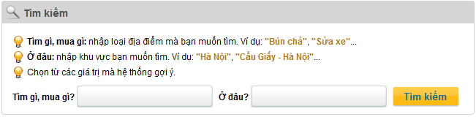

“Tìm gì, mua gì” is for category searching and “Ở đâu” is for address part searching. There is a suggest list displayed below as you typing:

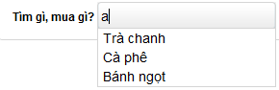

After inputting information, you have to click to “Tìm kiếm” button to begin searching. If there isn’t any result which matches with conditions you typed, you will see a message: “Không tìm thấy địa điểm nào!”

Search engine just focus on Category. So if there isn’t result matches with Address Part typed, all places belongs to Category typed will be displayed. Besides, you can sort results easily by place’s rating, place’s view number and place’s comment number

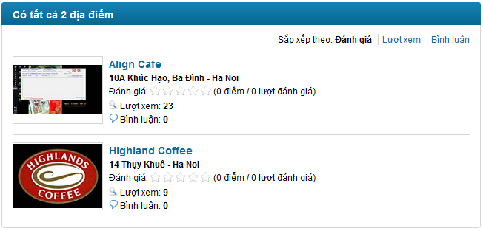

When you click to any place’s name, place’s details information will be displayed at [View Place Details](#_View_place_details_1) page.

### View place details

View place details page will be divided to 3 parts:

* Information

All information of place will be displayed including: detail address, phone number, category, rating, location on map, view number, visited number, description, images.

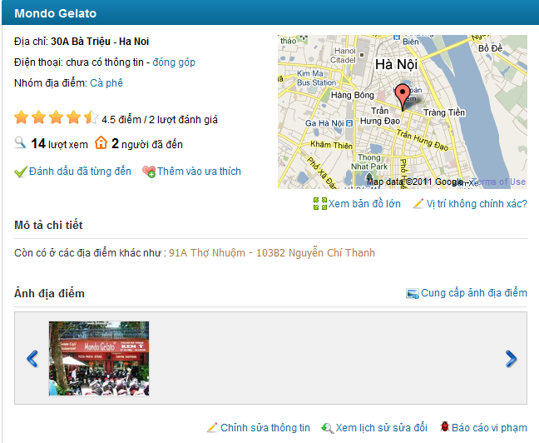

You can:

* Change place information by click to “Đóng góp” or “Chỉnh sửa thông tin” hyperlink.
* If default map is too small with you, you can click to “Xem bản đồ lớn” hyperlink to see larger map.
* if you realize that this place wasn’t located exactly? You can click to “Vị trí không chính xác?” hyperlink and choose location you think it’s true. This can also be done by clicking to “Chỉnh sửa thông tin” hyperlink and edit place location.
* You can upload pictures for current viewing place by click to “Cung cấp ảnh địa điểm” hyperlink.
* You can rate a place base on your opinion.
* If you has visited the place you are viewing in the past, you can click to “Đánh dấu đã từng đến” hyperlink. Visited number make the place is trustable.
* You can add a place to your favorite list
* You Can view edit history of a place

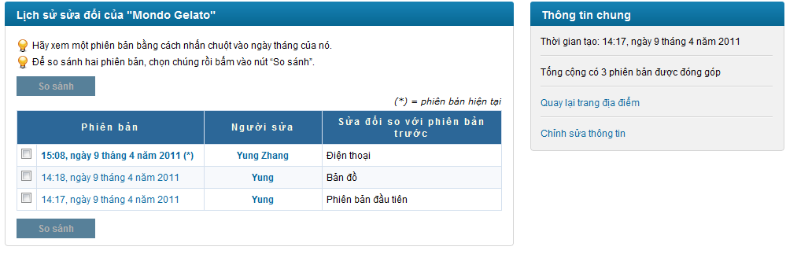

You can view edited information between 2 version by choose 2 revisions and click to “So sánh” button. A new popup will appear and show content of 2 revisions with differences displayed in red background.

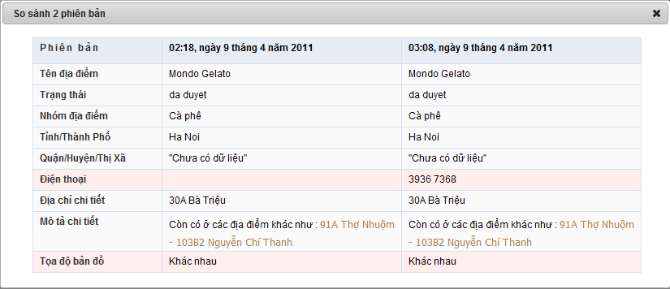

* You can report a place as spam by click to “Báo cáo vi phạm” hyperlink. We always welcome your support to build a better website.
* Comments

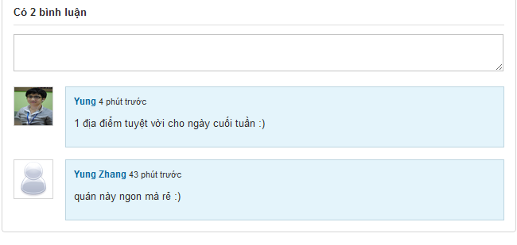

This part displays all comments of current place. Each comment has information of creator, created time and content.

**Take a notice: you need log in first to be able to post, vote, report or delete comments.**

You can vote for comments that weren’t post by yourself by click to thumb up or thumb down symbol. Or you can report it as spam by click to flag symbol.

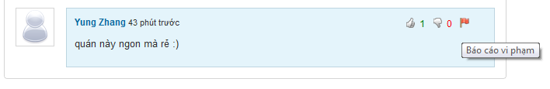

With your own comment, you can’t click to thumb up, thumb down symbol and flag symbol is replaced by X symbol which used for delete your comment

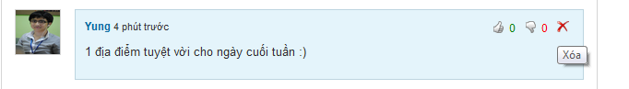

You can post a comment by typing into text box and click to “Bình luận” to or click to “Bỏ qua” button to cancel this action.

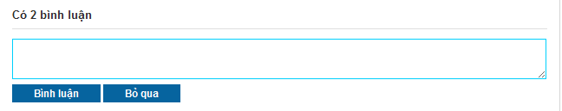

* Suggest other places which has relation to current place

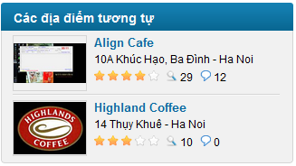

### View question and answer

#### View Q&A page

To view Q&A page, you need click to “Hỏi & Đáp” menu in navigator.

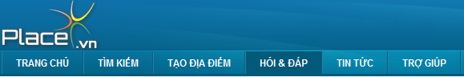

At this page, If you want to create a new question, you can click to “Gửi câu hỏi mới” hyperlink and [“Tạo câu hỏi mới”](#_Create_a_new) page will be opened.

Each question is displayed with: creator, created tine, Title, view number, answer number, vote up and down number

If you want to view question details, click to question title.

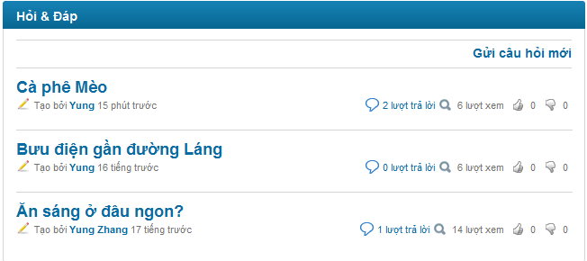

On the right side of Q&A page will show 10 hottest questions (based on views) and most contributors (based on number of answers posted by these users). All information will be updated each hour.

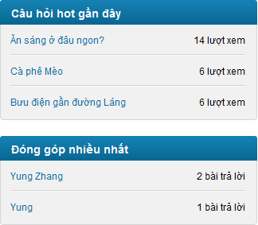

#### View question details

Go to question detail page by clicking to question title hyperlink.

**Take notice that:**

* + **You can’t vote for your own question**
  + **You must log in to be able to vote question, report question or post answer.**
  + **You can only edit your own question**

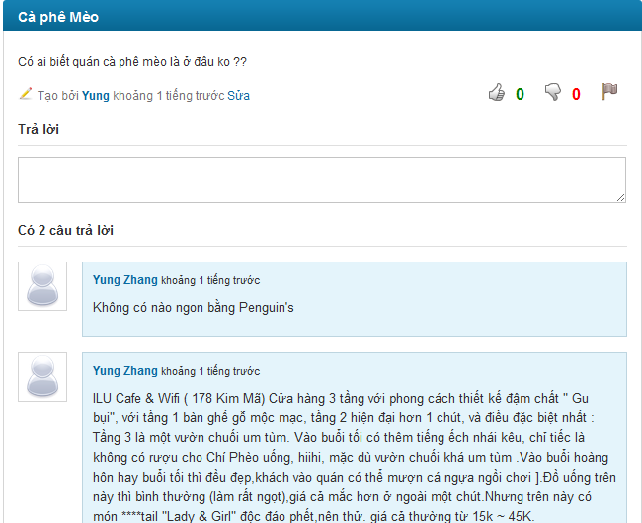

* You can Report question as spam by clicking to “Báo cáo vi phạm” button. You can input reason in pop-up before clicking to “Báo cáo” button (reason isn’t required)

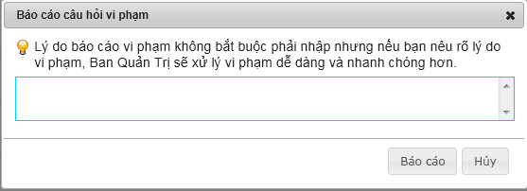

* The way to post answer, vote question, vote answer you can reference to post new comment at [View place details](#_View_place_details)

### View other user’s profile

To view a user profile, you need to click to that user name (displayed as hyperlink). Other user profile page includes some basic information such as: name, avatar, created date, user point, number of place created by this user, number of comment, question and answer posted by this user.

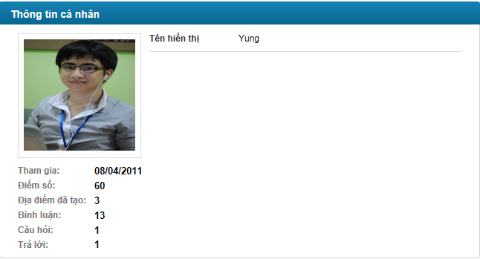

## Form Guide



### Register a new PSN account and Activation

To be able to access all functions for users on our system, you should register an account or using your Google account or Yahoo account.

Registering a PSN account can be done by following steps:

* Click to “Đăng kí” button on register panel on the top right corner of the website. This panel is always visible for everyone at every page.

C:\Users\iLucas\Desktop\reg panel.png

* You will be redirected to register page with register form:

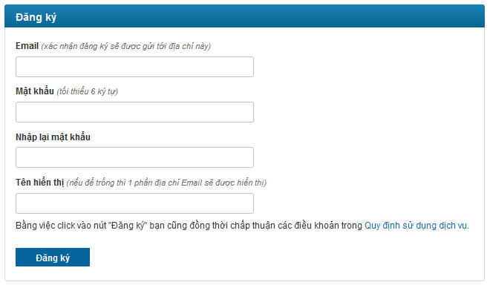

* Enter your valid email. Each email can only be used for registering once. Your mail must be valid in order to get activation email from our system.
* Enter your password and re-enter it again. 2 passwords must be matched
* Enter your desired display user name. If you leave this text box blank, your display user name will be generated from your email address.

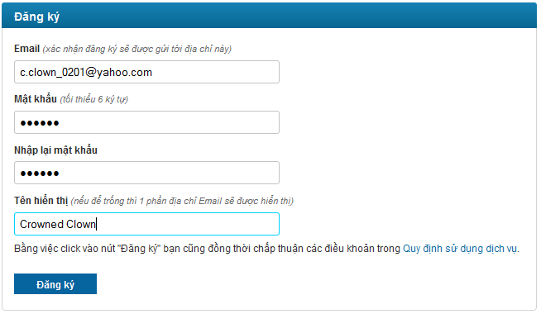

* Click “Đăng ký” button. Success message will be displayed:

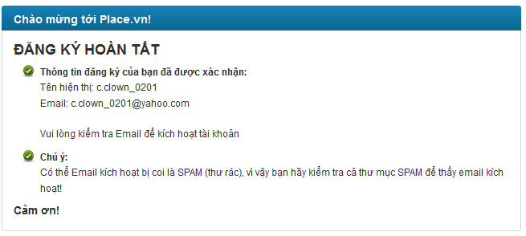

* An activation email will be sent to your registered email address

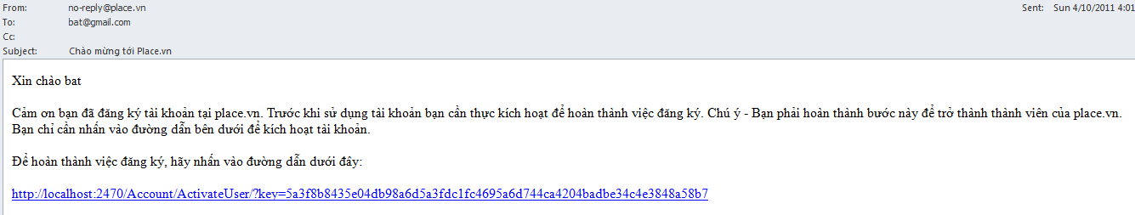

* Click to hyperlink in email and your account will be active

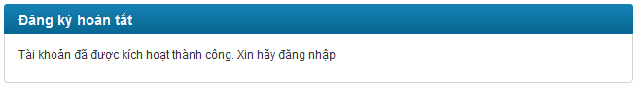

### Forgot password

This feature is just used with Place.vn account.

Sometimes because of any reason, you forget password, so you can’t login to website by place.vn account. Don’t worry because you can recover password by following steps:

* Click “Đăng nhập” button at the top of the page

C:\Users\iLucas\Desktop\reg panel.png

* You will be redirected to login page



* Click “Quên mật khẩu” button.

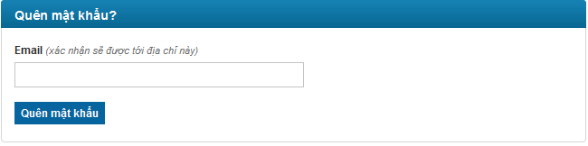

* Enter your email and click “Quên mật khẩu” button. Success message will be displayed

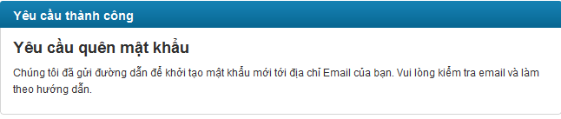

* Confirmation email will be sent to your registered email address

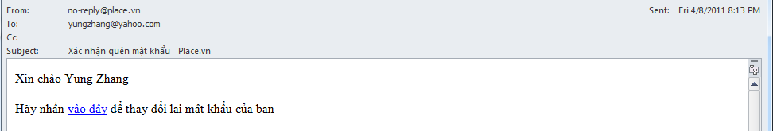

* Click to “vào đây” hyperlink in email
* Enter your password and re-enter it again. 2 passwords must be matched. Click “Thay đổi” button

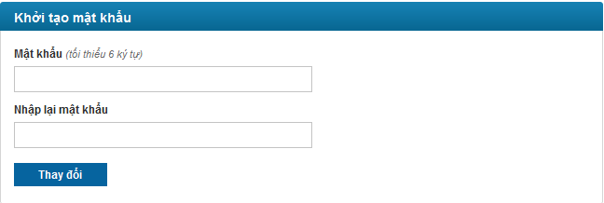

* Success message will be displayed

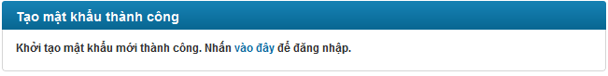

* You can login with your PSN account and above password.

### Create a new place

* To create a new place, click to “Tạo địa điểm” in the main menu at head page.

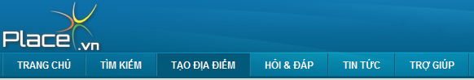

* You will be redirected to Create Place Page.

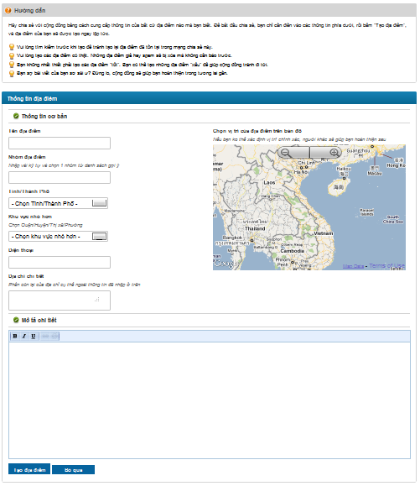

* First, fill in basic information for new place as following form:

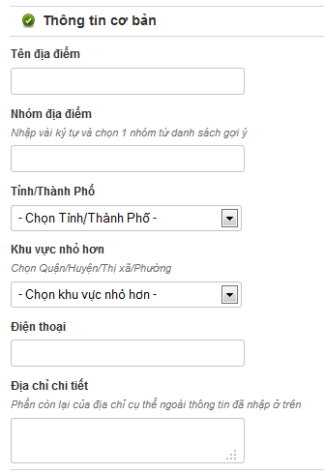

* + “Tên địa điểm”: enter place name. This is required and must be lesser than 200 characters
  + “Nhóm địa điểm”: enter place category. This is required. There will be a suggest list displayed below as you typing into the text box. You must choose 1 category from suggested list. If your category is different, you can’t create a new place. You can only create place for valid categories in the system

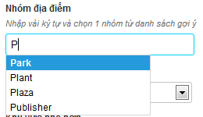

* + “Tỉnh/Thành phố”: choose province or city from list. You can’t enter new province or new city
  + “Quận/huyện/thị xã/phường”: choose district, town and ward from list. You can’t enter new district, new town or new ward.
  + “Điện thoại”: enter place phone number
  + “Địa chỉ chi tiết”: enter place detail address, all remains part of place’s address except parts that was selected from 2 combo boxs above.
* Fill in detail description, comment, review… about new place:

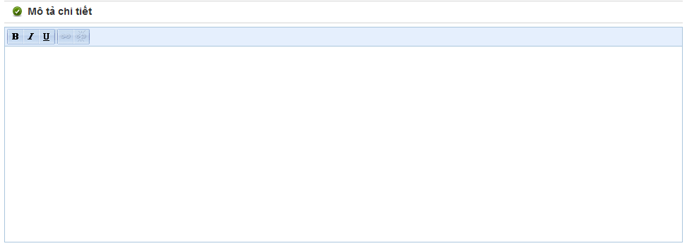

* Mark the place in map

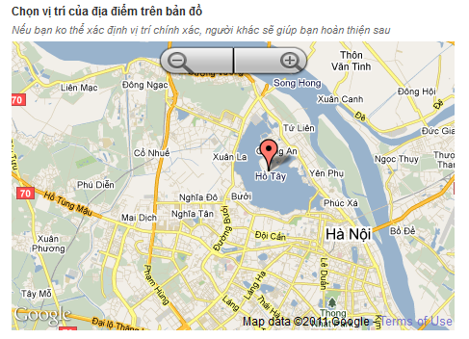

* Final, click to “Tạo địa điểm” button or cancel creating by click to “Bỏ qua” button. Click to “Tạo địa điểm” button will redirect you to detail page of new place. Click to “Bỏ qua” button will redirect you back to home page.

### Create a new question

* To create a new question, first you need to go to “Hỏi & Đáp” page by clicking to “Hỏi & Đáp” tab in main menu at head page



* You will be redirect to Q&A page. At Q&A page, click to “Gửi câu hỏi mới”.

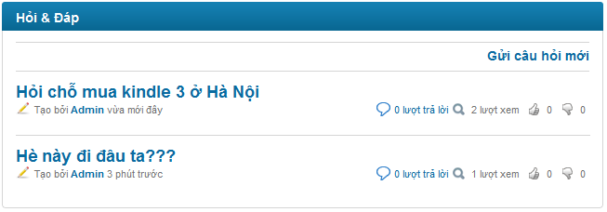

* You will be redirect to Create Question page

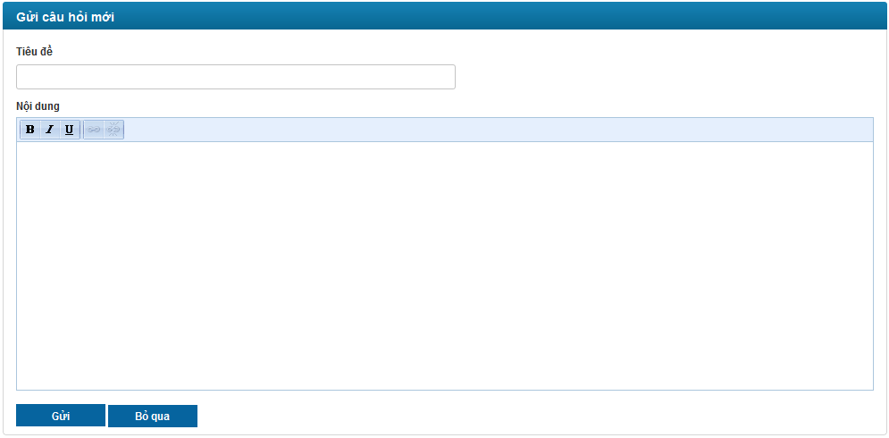

* + “Tiêu đề”: enter question’s title. This is required and must be lesser than 100 characters
  + “Nội dung”: enter question’s content. This is required.
* Click to “Gửi” button to post new question. You will be redirect to Question Detail page of new question
* If you don’t want to post new question. Click to “Bỏ qua” button and get redirected back to Q&A page

### Create an answer

You can post answer for question by enter answer content into text area below “Trả lời”.

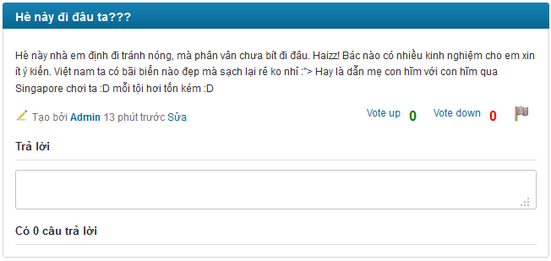

Click to text area, 2 button will appear: “Trả lời” and “Bỏ qua”

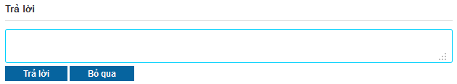

Enter your answer. Take notice that you can’t post a blank answer.

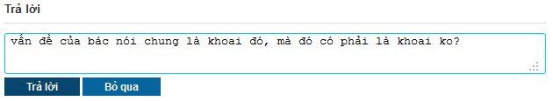

Click to “Trả lời” button, your answer will be posted and displayed at answer area. If you don’t want to post your answer anymore, click to “Bỏ qua” button and answer text box will be back to normal.

### Create a new contact

You can contact with us by create new contact. Do as following:

* Click to “Liên hệ” tab at bottom of web page



* You will be redirect to Contact page

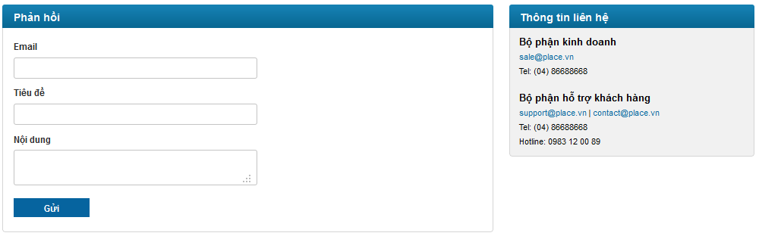

* Fill in your email address. This address must be valid in order to get our reply.
* Fill in the title and content of the message you want to send to us
* Finally, click to “Gửi” button

## Admin Guide



### Manage Places

#### Unlocated Places

All unlocated places will be displayed in this page. To locate any place, you click to “Set location” button at row which contains that place.

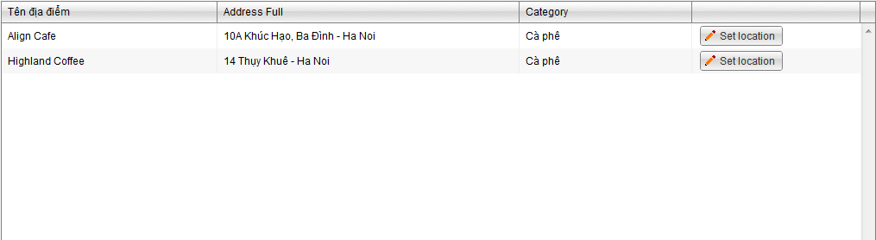

You choose location in the map which is displayed in pop-up then click to “Save” button. So message “***location set successfully”*** will replace position of Set location button. Press F5 and that place will be removed from list of this page.

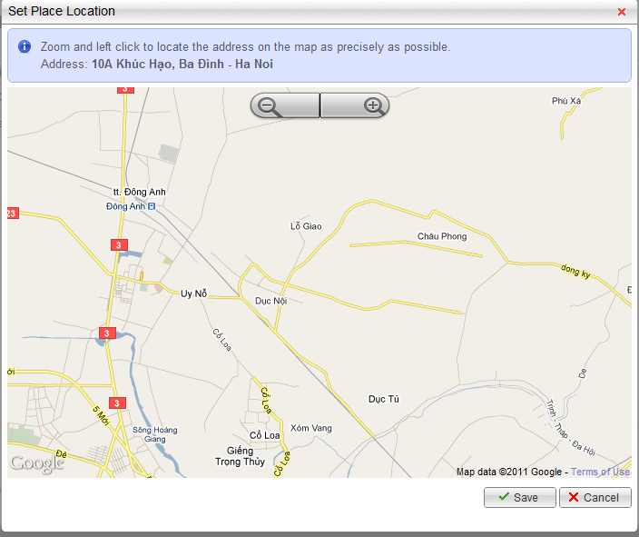

#### Featured Places

Featured place is place which has paid to have high rank in searching result of any category in a period of time.

You can create new featured place by clicking to “Create a new record” button. Next, input required information including:

* Place Id: id of place. When you input this Id, Place Name will be displayed automatically at the Place Name field. (Default value is 0)
* Category Name: category which place belongs to.
* Rank: rank you want place has (only from 1 to 3)
* Valid From: beginning of featured time.
* Valid To: ending of featured time. This time must later than Valid From

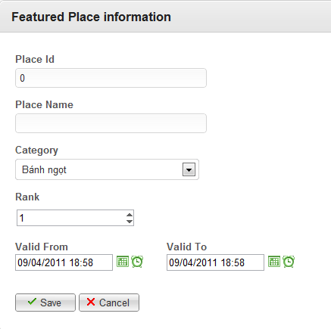

After inputting all required information, click “Save” button to finish. This place will be display at the list of Featured Places immediately. You can edit or delete this place anytime you want.

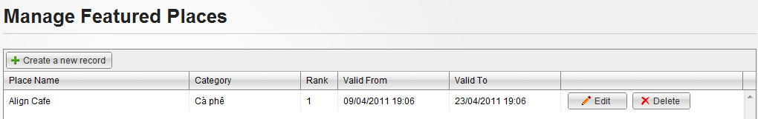

### Manage Spam

Go to admin page and click to Spam menu on the right side to see 4 sub menus: Reported Places, Reported Comments, Reported Questions and Reported Answers. Click to 1 of 4 sub menus to go to correspond manage page.

#### Manage Reported Places

This page will display places reported as spam

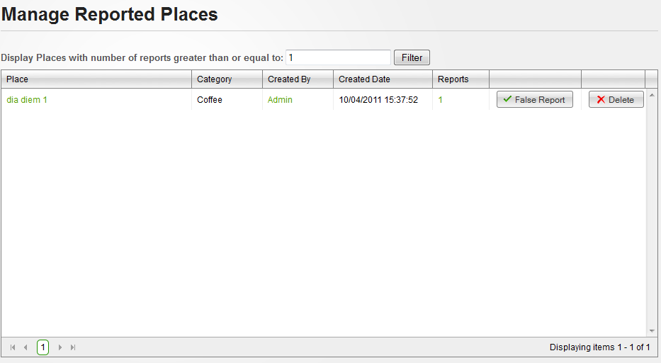

Each reported place will be displayed with place name, place’s category, place’s creator name, place’s created date, number of times get reported and 2 button “False Report” and “Delete”

There is a filter helps you get reported places with expected report number:



You can click to place name hyperlink to view detail reported place, click to creator name hyperlink to view information about the creator or click to report number to view detail of all reports (Who report, when and what reason) in a popup

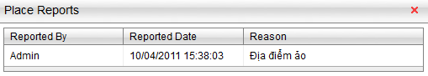

After checking all need information. If you decide that the place was falsely reported, click to “False Report” button to delete all reports belong to selected place. If not, click to “Delete” button to delete selected place and all reports belong to it.



#### Manage Reported Comments

This page will display comments reported as spam

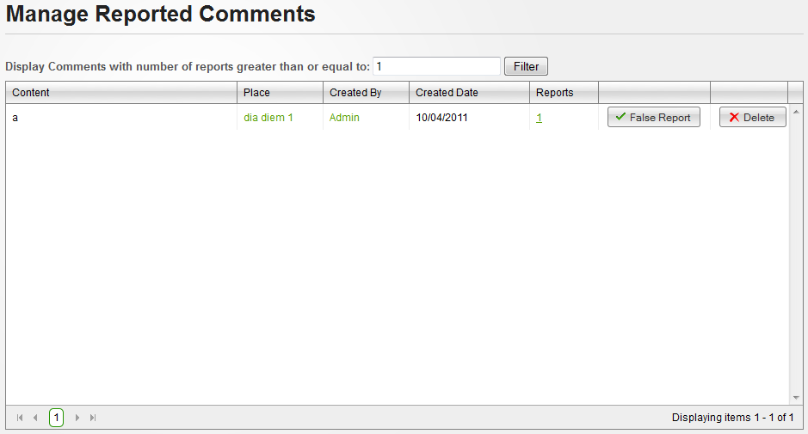

Each reported comment will be displayed with content, comment’s place, comment’s creator name, comment’s created date, number of times get reported and 2 button “False Report” and “Delete”

There is a filter helps you get reported comment with expected report number:



You can click to place name hyperlink to view detail of the place the comment belong to, click to creator name hyperlink to view information about the creator or click to report number to view detail of all reports (Who report, when and what reason) in a popup

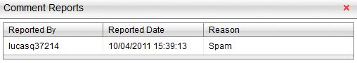

After checking all need information. If you decide that the comment was falsely reported, click to “False Report” button to delete all reports belong to selected comment. If not, click to “Delete” button to delete selected comment and all reports belong to it.



#### Manage Reported Questions

This page will display questions reported as spam

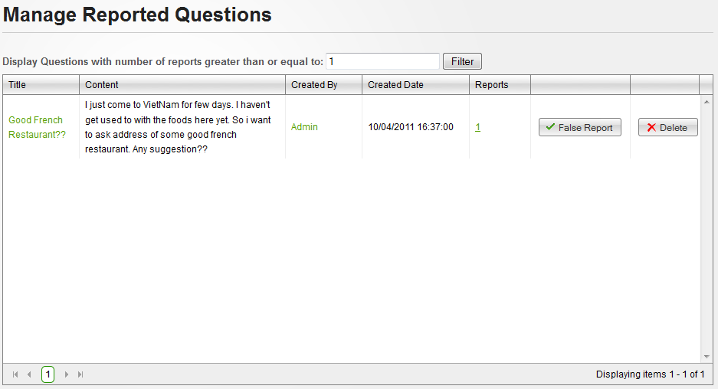

Each reported question will be displayed with question title, content, creator name, created date, number of times get reported and 2 button “False Report” and “Delete”

There is a filter helps you get reported questions with expected report number:



You can click to question title hyperlink to view detail reported question, click to creator name hyperlink to view information about the creator or click to report number to view detail of all reports (Who report, when and what reason) in a popup

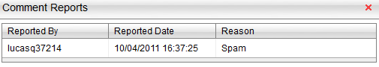

After checking all need information. If you decide that the place was falsely reported, click to “False Report” button to delete all reports belong to selected question. If not, click to “Delete” button to delete selected question and all reports belong to it.



#### Manage Reported Answers

This page will display answers reported as spam

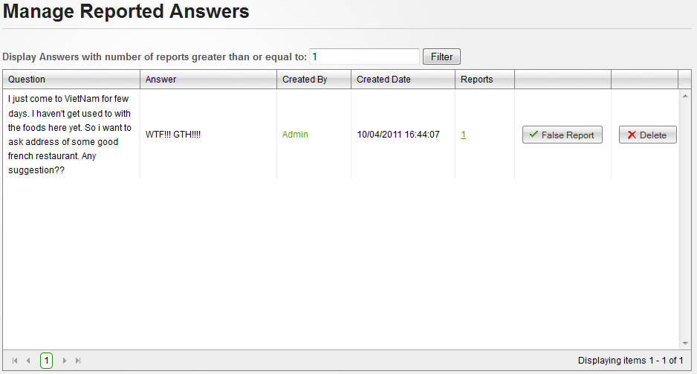

Each reported answer will be displayed with question content, answer content, answer’s creator name, answer’s created date, number of times get reported and 2 button “False Report” and “Delete”

There is a filter helps you get reported answers with expected report number:



You can click to creator name hyperlink to view information about the creator or click to report number to view detail of all reports (Who report, when and what reason) in a popup

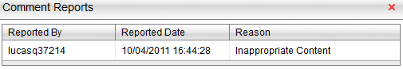

After checking all need information. If you decide that the place was falsely reported, click to “False Report” button to delete all reports belong to selected answer. If not, click to “Delete” button to delete selected answer and all reports belong to it.



### Manage Users

#### Manage Users

This page manages all users existed in the sytem.

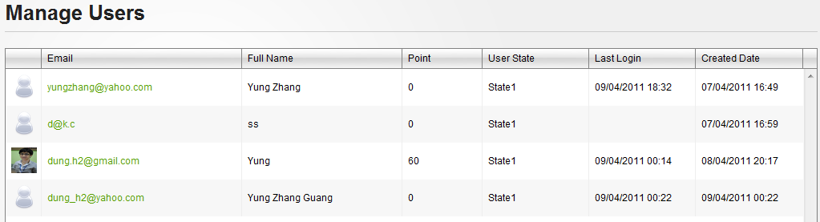

You can view user details by clicking to Email hyperlink of any user you want. View Details User page will appear including some information: Email, Full Name, Point, User State, Roles, Last Logged in, and Registered Date. At this page, you can delete user by clicking to “Delete” button or click to “Edit” button to change user’s information.

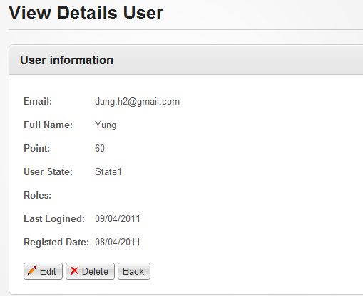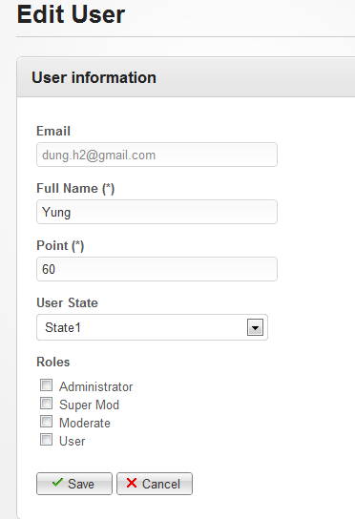

At Edit User page, you can change all user’s information except email. Click to “Save” button to save changes or “Cancel” to return to previous page.

#### Manage Roles

This page manages all roles which are used in website. You can delete any role by clicking to “Delete” button at same row which contains that role.

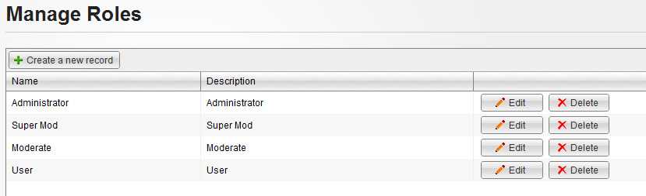

If you want to create a new role: click to Create a new record at the below of title page. Create a Role page will appear as the below picture. Name is required and must not exist in database while Description and Permission are not. Finally, you have to click to “Save” button to finish creating. A notification will be displayed at the top of page, announce creating successfully.

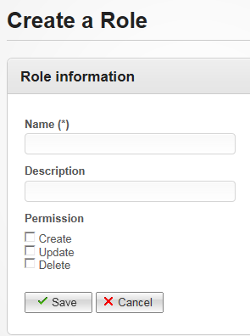

If you want to change some information of created role in the past, click to Edit button at same row which contains that role. Edit a role page will appear as same as the below picture. You can change anything you want before clicking to Save button to confirm changes.

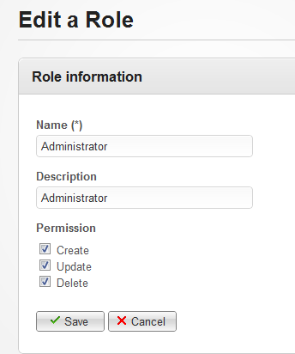

### Manage Categories

This page manages all categories which are used in website. You can delete any category by clicking to “Delete” button at same row which contains that category.

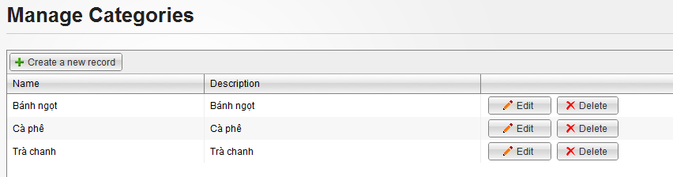

If you want to create a new category: click to Create a new record at the below of title page. Create a Category page will appear as the below picture. Name is required and must not exist in database while Description and Alternative Names are not. Finally, you have to click to “Save” button to finish creating. A notification will be displayed at the top of page, announce creating successfully.

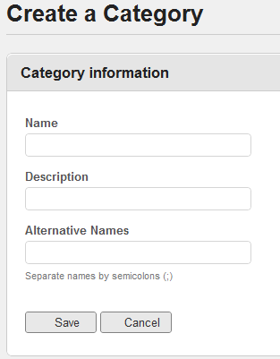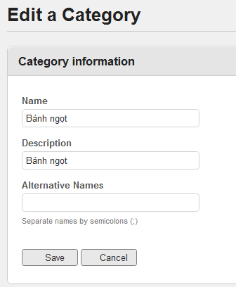

If you want to change some information of created category in the past, click to Edit button at same row which contains that category. Edit a category page will appear as same as the below picture. You can change anything you want before clicking to Save button to confirm changes.

### Manage Address Parts

This page manages all address parts which are used in website. You can delete any address part by choosing that address in the tree then clicking to “Delete” button at the bottom.

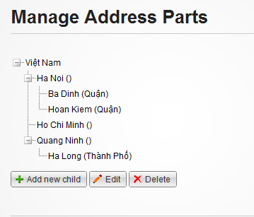

If you want to create a new address part: click to Add new child at the bottom of tree view. Create an Address Part page will appear as the below picture. You can input Name and Prefix, locate address on the map. Finally, you have to click to “Save” button to finish creating. A notification will be displayed at the top of page, announce creating successfully.

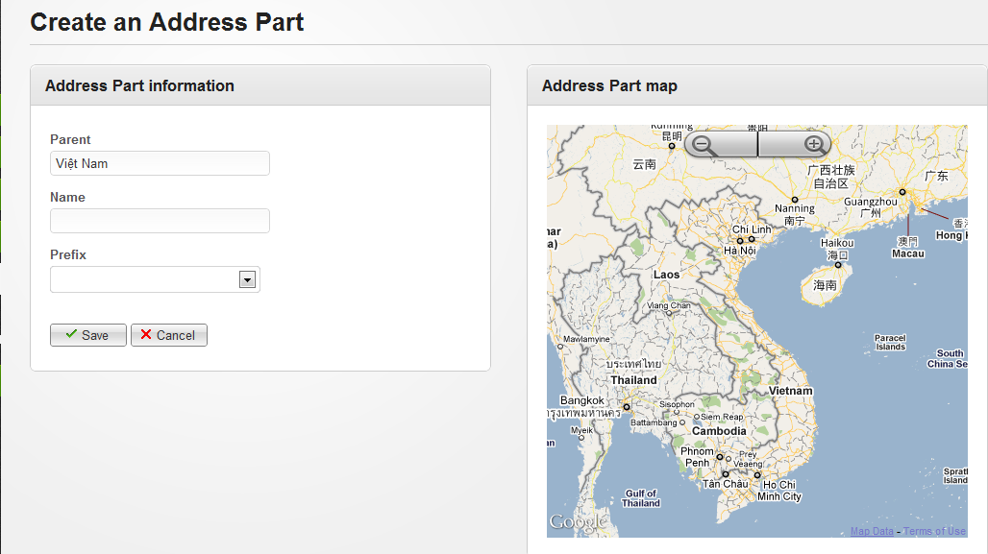

If you want to change some information of created address part in the past, choose that address part and click to “Edit” button at the bottom of page. Edit Address Parts page will appear as same as the below picture. You can change anything you want before clicking to Save button to confirm changes.

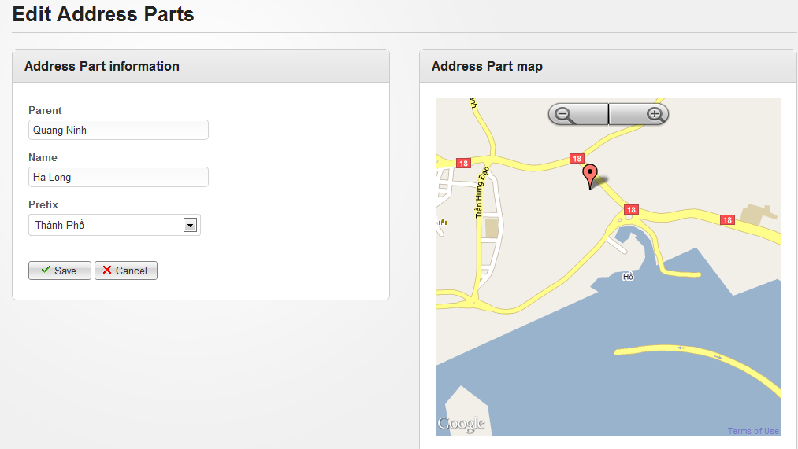

### Manage Contacts

This page manages all contacts which are sent from user. You can sort them follow conditions: Checked, Uncheck and All by choosing any condition in drop down list then clicking to “Filter” button.

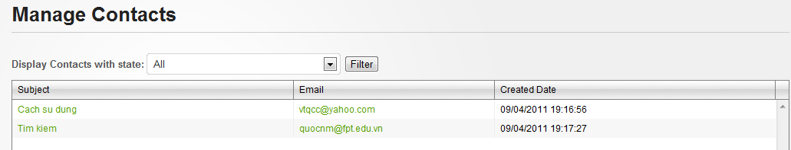

You can view contact details by clicking Subject hyperlink of any contact. You can see Subject and content of message. After reading, you click to “Mark as Checked” so that we can ignored it at another checking. You can also click to Email hyperlink at Manage Contacts page to send your reply to that user.

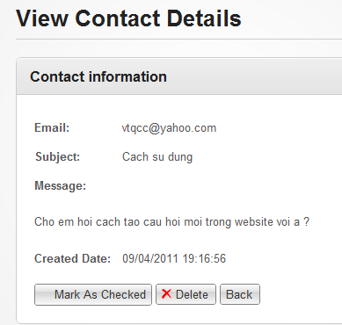

# Others